**Zhumagali Kanat IT2-2003**

**Lab2. Creating anonymous blocks**

1. Create 6 anonymous blocks for your database (Lab 1) with the functionality according to the database domain.
2. At least three blocks must include explicit cursors.
   1. For the cursors, use the traditional way of processing them two times and the *Cursor For Loop* structure – once.
   2. One of the cursors that you create needs to be with parameters.
   3. Cursors must be used correctly, according to their functionality!!!
3. Additionally, the anonymous blocks must include:
   1. creating and application of at least one record;
   2. creating and application of at least one INDEX BY table;
   3. application of the control structures, such as IF, loops, CASE.
4. For loop fetch

declare

cursor sal_cursor is select movie_id, film_name, duration, year_of_release from movie where YEAR_OF_RELEASE > 2000 order by year_of_release asc;

begin

for sal_record in sal_cursor loop

dbms_output.put_line('Movie id : ' || sal_record.movie_id || ' Film name : ' || sal_record.film_name || ' Duration: ' || sal_record.duration || ' Year of release: ' || sal_record.year_of_release );

end loop;

end;

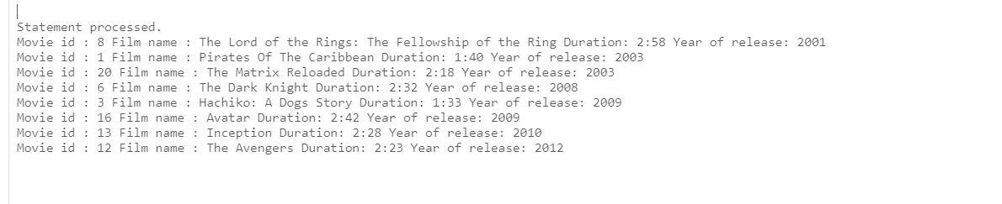

2. fetch with parametrs

declare

--cursor movie_act_cursor is select movie_id, film_name, year_of_release, last_name, first_name, date_of_birth from movie, actors, movie_cast where movie.movie_id = movie_cast.movie_id and actors.actor_id = movie_cast.actor_id;

cursor movie_act_cursor is select movie_id, actor_id from movie_cast where mod(movie_id, 2) = 0;

cursor movie_act_cursor_info(mov_id number) is

select m.movie_id, m.film_name, m.year_of_release, a.last_name, a.first_name, a.date_of_birth from movie m, actors a, movie_cast mc where m.movie_id = mc.movie_id and a.actor_id = mc.actor_id and mc.movie_id = mov_id ;

m_id movie.movie_id%type;

a_id actors.actor_id%type;

m_id_i movie.movie_id%type;

film_name movie.film_name%type;

yor_i movie.year_of_release%type;

l_name actors.last_name%type;

f_name actors.first_name%type;

dob_i actors.date_of_birth%type;

begin

open movie_act_cursor;

loop fetch movie_act_cursor into m_id, a_id;

exit when movie_act_cursor%notfound;

dbms_output.put_line(m_id || ' ' || a_id);

open movie_act_cursor_info(m_id);

loop fetch movie_act_cursor_info into m_id_i, film_name, yor_i, l_name, f_name, dob_i;

exit when movie_act_cursor_info%notfound;

dbms_output.put_line('Movie id: ' || m_id_i ||' Film name: ' || film_name || ' Year of release: ' || yor_i || ' Actor name: ' || l_name || ' ' || f_name || ' DoB: ' || dob_i );

end loop;

close movie_act_cursor_info;

end loop;

close movie_act_cursor;

end;

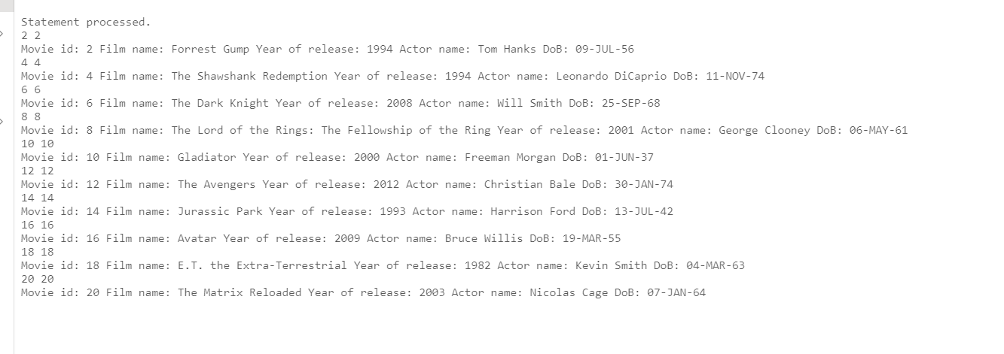

3.fetch for loop with parametrs

DECLARE

cursor genre_cursor is select genre_id, genre_name from genre where genre_name = 'Action';

cursor movie_g_info(g_id number) is

select m.movie_id, m.film_name, m.year_of_release from movie m join movie_genre mg on mg.movie_id = m.movie_id where mg.genre_id = g_id ;

begin

for genre_rec in genre_cursor loop

dbms_output.put_line(genre_rec.genre_id || ' Genre name: ' || genre_rec.genre_name );

for movie_genre_info_rec in movie_g_info(genre_rec.genre_id) loop

dbms_output.put_line('Movie id: ' || movie_genre_info_rec.movie_id ||' Film name : ' || movie_genre_info_rec.film_name|| ' Year of release: ' || movie_genre_info_rec.year_of_release );

end loop;

end loop;

end;

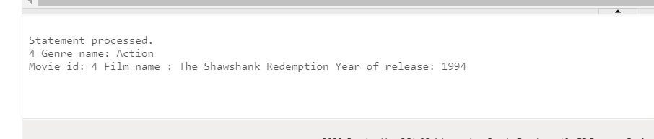

4.record type and cursor

declare

type movie_info is record(

movie_id movie.movie_id%type,

film_name movie.film_name%type,

duration movie.duration%type,

rating_imbdb movie.rating_imbdb%type

);

my_id number;

m_info movie_info;

cursor m_info_cursor is select movie_id, film_name, duration,rating_imbdb from movie where movie_id = my_id;

begin

my_id := '2';

open m_info_cursor;

fetch m_info_cursor into m_info;

close m_info_cursor;

dbms_output.put_line(m_info.movie_id || ' ' || m_info.film_name || ' ' || m_info.duration);

end;

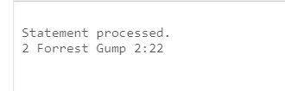

5.index by and for loops

declare

type companies_name is table of Film_Production_Companies.prod_name%type index by pls_integer;

c_table companies_name;

counter pls_integer := 0;

begin

for rec in (select prod_name from Film_Production_Companies) loop

counter := counter + 1;

c_table(counter) := rec.prod_name;

dbms_output.put_line(counter ||' Name of company: ' || c_table(counter));

end loop;

end;

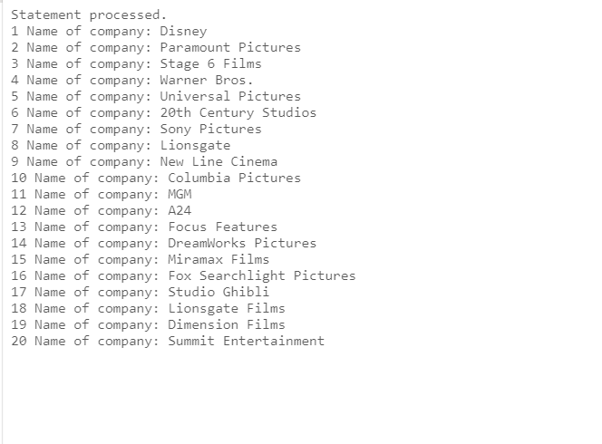

6. if case using records+cursors

declare

type movie_fin_info is record(

movie_id movie.movie_id%type,

film_name movie.film_name%type,

budget finance.budget%type,

income finance.income%type

);

m_info movie_fin_info;

my_b number;

cursor fin_cursor is select m.movie_id, m.film_name, f.budget, f.income from movie_fin mf join movie m on mf.movie_id = m.movie_id join finance f on mf.fin_id = f.fin_id;

begin

my_b := 1000000;

for fin_record in fin_cursor loop

m_info := fin_record;

if(to_number(m_info.budget) > my_b) then dbms_output.put_line('||Film name: ' || m_info.film_name || ' has budget: ' || m_info.budget || ' and his income: ' || m_info.income || '||');

else dbms_output.put_line(m_info.film_name || ' has budget whis is less ' || my_b);

end if;

end loop;

end;

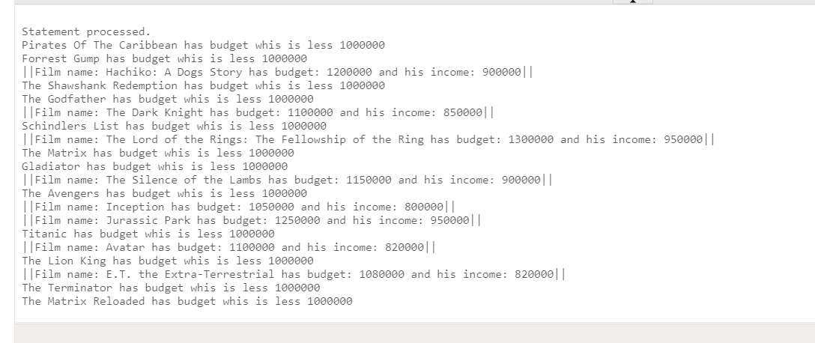

Questions:

1. Describe the structure of an anonymous block
2. What types of blocks exist in PL/SQL?
3. The rules to declare variables
4. What types of composite data types do you know?
5. What is the main difference between records and INDEX BY tables?
6. Show how to create records (2 ways)
7. Show how to create INDEX BY table
8. The use of %TYPE attribute
9. The use of %ROWTYPE attribute
10. The types of loops
11. The types of CASE
12. Implicit cursors and their attributes
13. Explicit cursors
14. The attributes of explicit cursors
15. What happens when we **declare** an explicit cursor?
16. What happens when we **open** the explicit cursor?
17. What happens when we **fetch** the explicit cursor?
18. What happens when we **close** the explicit cursor?